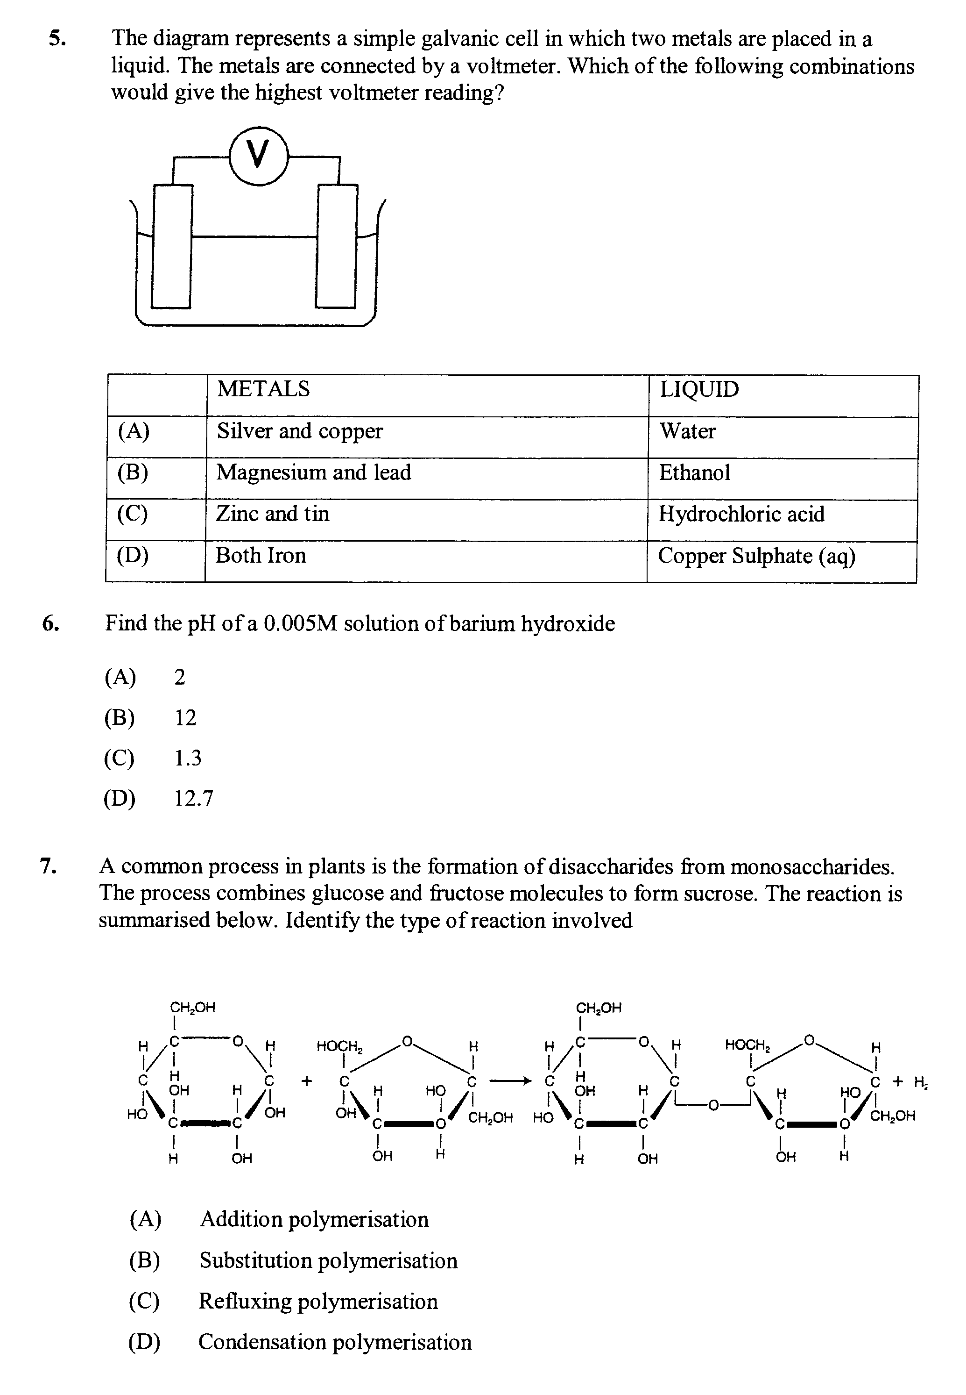
FORT STREET – TRIALS EXAMINATION 2009
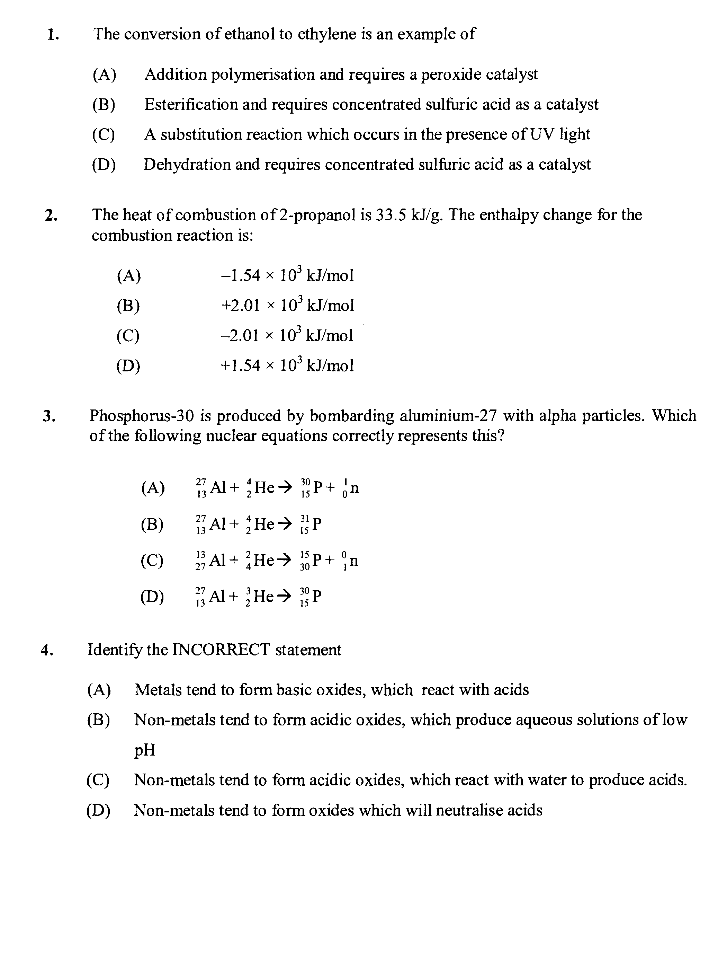

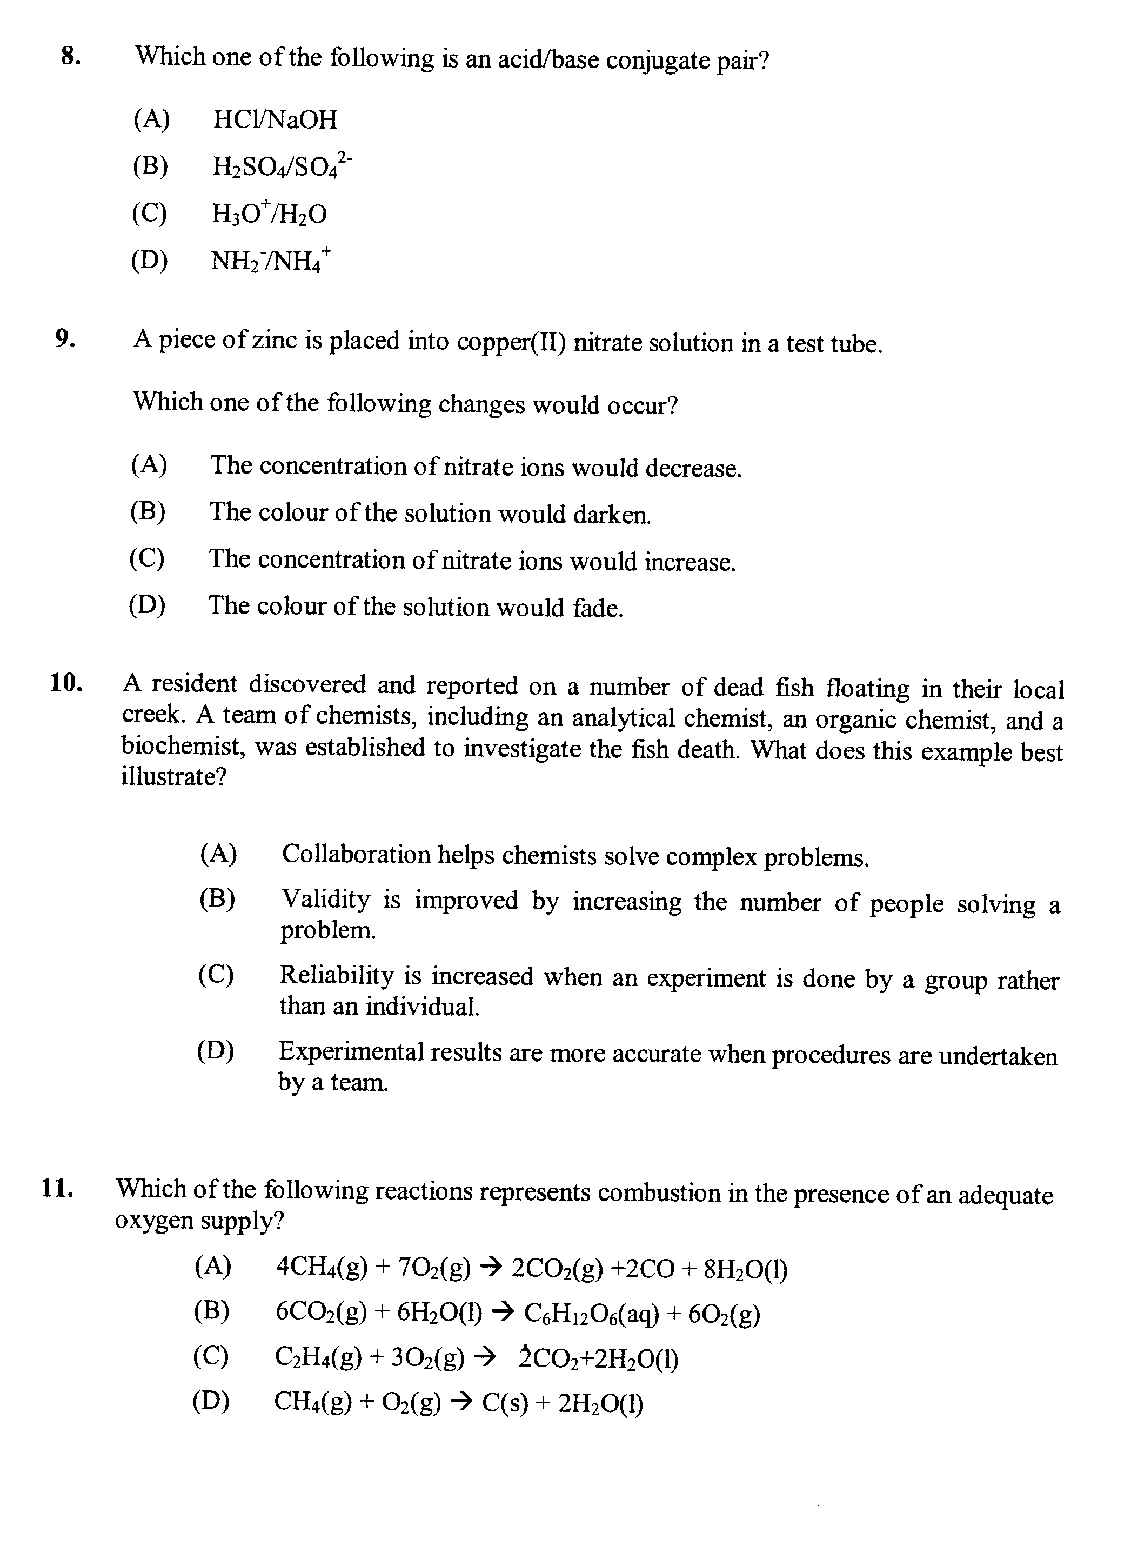
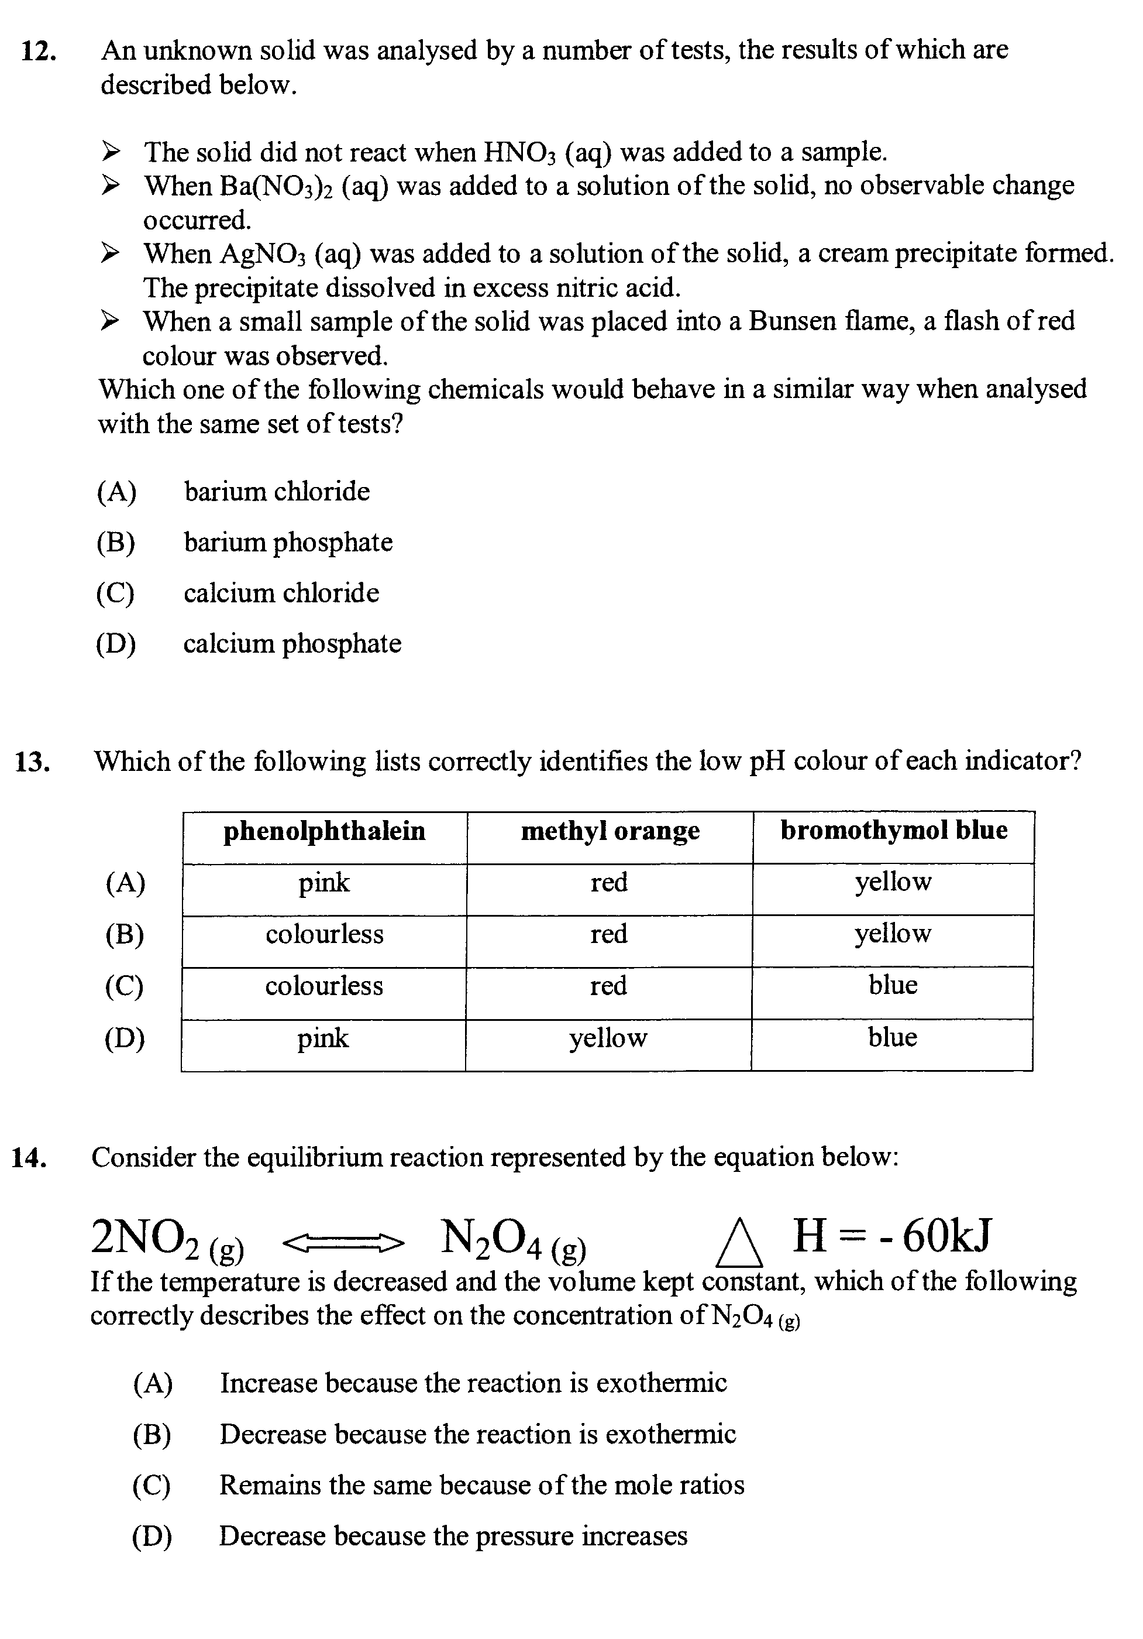

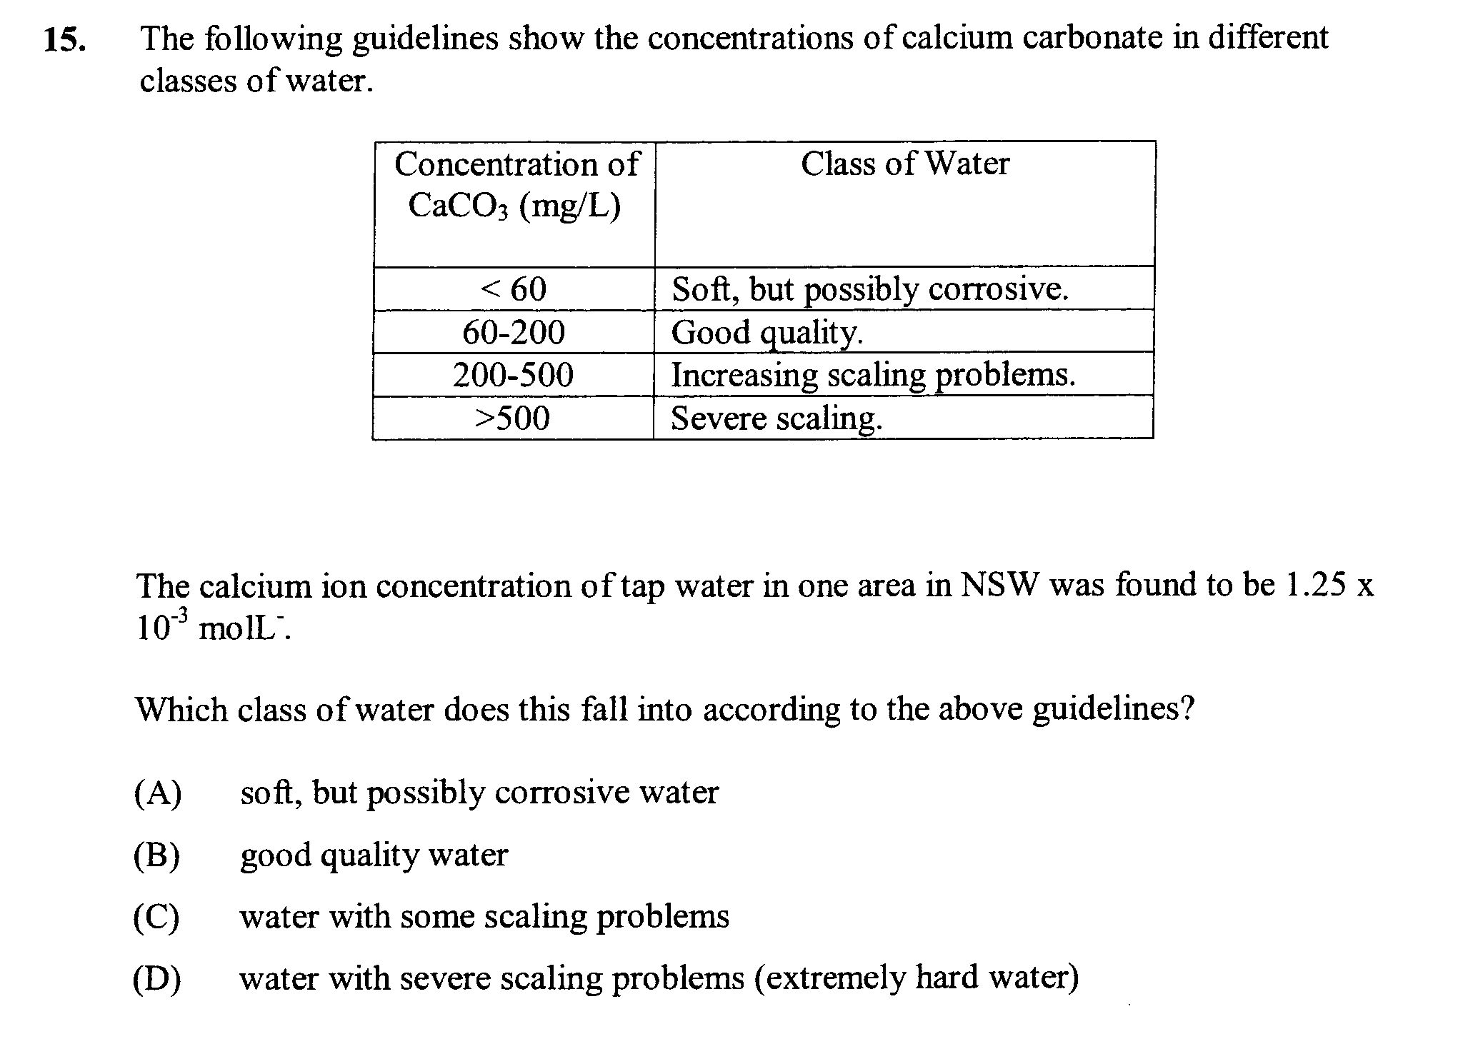

Part B
Attempt questions 16-29
Allow about 1 hour and 45 minutes for this part
______________________________________________________

Question 16 (6 marks)

During your HSC course you planned and performed a first hand investigation to monitor the mass changes during the fermentation of glucose

a. Draw a fully labelled scientific diagram of the equipment assembled for the experiment 2

b. Outline the steps involved in your investigation including a balanced chemical equation 2

…………………………………………………………………………………………………………………

…………………………………………………………………………………………………………………

…………………………………………………………………………………………………………………

…………………………………………………………………………………………………………………

…………………………………………………………………………………………………………………

…………………………………………………………………………………………………………………

…………………………………………………………………………………………………………………

…………………………………………………………………………………………………………………

…………………………………………………………………………………………………………………

…………………………………………………………………………………………………………………

Question 16 continued

c. The mass changes during a fermentation reaction were carefully monitored. The mass of the 2
reaction mixture decreased by 50.0 g. Calculate the mass of ethanol produced

…………………………………………………………………………………………………………………

…………………………………………………………………………………………………………………

…………………………………………………………………………………………………………………

…………………………………………………………………………………………………………………

…………………………………………………………………………………………………………………

…………………………………………………………………………………………………………………

…………………………………………………………………………………………………………………

…………………………………………………………………………………………………………………

…………………………………………………………………………………………………………………

…………………………………………………………………………………………………………………

…………………………………………………………………………………………………………………

Question 17 (2 marks)

Describe using a specific example the recent discovery of a named element

…………………………………………………………………………………………………………………

…………………………………………………………………………………………………………………

…………………………………………………………………………………………………………………

…………………………………………………………………………………………………………………

…………………………………………………………………………………………………………………

…………………………………………………………………………………………………………………

…………………………………………………………………………………………………………………

…………………………………………………………………………………………………………………

…………………………………………………………………………………………………………………

…………………………………………………………………………………………………………………

Question 18 (6 marks)

Outline the way that the concept of an acid has developed from the time of Humphrey Davy in the early 1800’s to the Bronsted-Lowry Theory in the 1920’s. Include relevant formula and/or equations

…………………………………………………………………………………………………………………

…………………………………………………………………………………………………………………

…………………………………………………………………………………………………………………

…………………………………………………………………………………………………………………

…………………………………………………………………………………………………………………

…………………………………………………………………………………………………………………

…………………………………………………………………………………………………………………

…………………………………………………………………………………………………………………

…………………………………………………………………………………………………………………

…………………………………………………………………………………………………………………

…………………………………………………………………………………………………………………

…………………………………………………………………………………………………………………

…………………………………………………………………………………………………………………

…………………………………………………………………………………………………………………

…………………………………………………………………………………………………………………

…………………………………………………………………………………………………………………

…………………………………………………………………………………………………………………

…………………………………………………………………………………………………………………

…………………………………………………………………………………………………………………

…………………………………………………………………………………………………………………

…………………………………………………………………………………………………………………

Question 19 (3 marks)

a. Describe the term buffer 1

…………………………………………………………………………………………………………………

…………………………………………………………………………………………………………………

- Buffers are important in many natural systems. Describe the effect of a buffer in a natural 2
system that you have studied

…………………………………………………………………………………………………………………

…………………………………………………………………………………………………………………

…………………………………………………………………………………………………………………

…………………………………………………………………………………………………………………

…………………………………………………………………………………………………………………

…………………………………………………………………………………………………………………

Question 20 (2 marks)

Sulfur dioxide can be removed from the exhaust gas of power stations by reacting it with calcium oxide to
form calcium sulfite. What mass of calcium oxide is needed to absorb 1 x 103 L of sulfur dioxide at 25ºC
and 100 kPa

…………………………………………………………………………………………………………………

…………………………………………………………………………………………………………………

…………………………………………………………………………………………………………………

…………………………………………………………………………………………………………………

…………………………………………………………………………………………………………………

Question 21 (2 marks)

Name two acids that are common food additives and give their formula or structure and use as a food additive.

…………………………………………………………………………………………………………………

…………………………………………………………………………………………………………………

…………………………………………………………………………………………………………………

…………………………………………………………………………………………………………………

Question 22 (5 marks)

How are esters prepared?
Include a risk assessment in your response.
Give an example with a balanced chemical equation and a practical use of the named ester formed

…………………………………………………………………………………………………………………

…………………………………………………………………………………………………………………

…………………………………………………………………………………………………………………

…………………………………………………………………………………………………………………

…………………………………………………………………………………………………………………

…………………………………………………………………………………………………………………

…………………………………………………………………………………………………………………

…………………………………………………………………………………………………………………

…………………………………………………………………………………………………………………

…………………………………………………………………………………………………………………

…………………………………………………………………………………………………………………

…………………………………………………………………………………………………………………

Question 23 (6 marks)

In a titration, a student finds that 30.0 mL of a 0.300 mol L⁻¹ sulfuric acid solution is needed to 3
react with 25.0 mL of sodium hydroxide solution

- Calculate the concentration of the sodium hydroxide solution in mol L⁻¹

…………………………………………………………………………………………………………………

…………………………………………………………………………………………………………………

…………………………………………………………………………………………………………………

…………………………………………………………………………………………………………………

…………………………………………………………………………………………………………………

…………………………………………………………………………………………………………………

…………………………………………………………………………………………………………………

…………………………………………………………………………………………………………………
b. Describe the correct technique for conducting this titration 3

…………………………………………………………………………………………………………………

…………………………………………………………………………………………………………………

…………………………………………………………………………………………………………………

…………………………………………………………………………………………………………………

…………………………………………………………………………………………………………………

…………………………………………………………………………………………………………………

…………………………………………………………………………………………………………………

…………………………………………………………………………………………………………………

…………………………………………………………………………………………………………………

…………………………………………………………………………………………………………………

…………………………………………………………………………………………………………………

Question 24 (5 marks)

The diagram shows THREE bottles of different acids
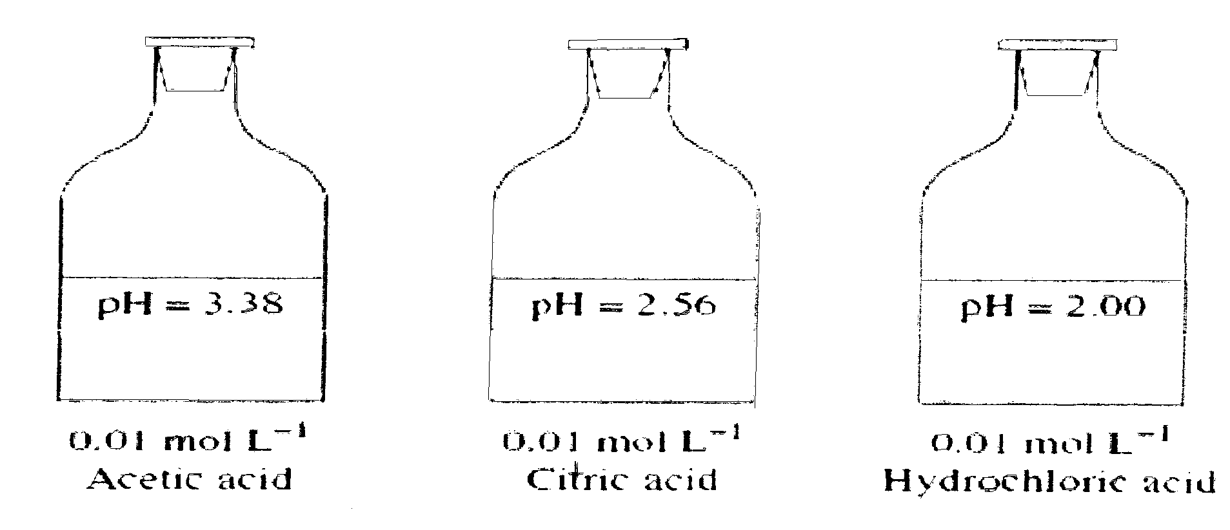

(i) Explain why the 3 acids have different pH values 2

…………………………………………………………………………………………………………………

…………………………………………………………………………………………………………………

…………………………………………………………………………………………………………………

…………………………………………………………………………………………………………………

…………………………………………………………………………………………………………………

(ii) A student, Celia was asked to make exactly 250 mL of a solution of an acid of pH = 4.00, using 3
the HCl from above. Calculate the dilution required and outline the steps she would take to
prepare the required solution

…………………………………………………………………………………………………………………

…………………………………………………………………………………………………………………

…………………………………………………………………………………………………………………

…………………………………………………………………………………………………………………

…………………………………………………………………………………………………………………

…………………………………………………………………………………………………………………

…………………………………………………………………………………………………………………

Question 25 (4 marks)

Describe with at least one chemical equation, an experiment you have performed to measure the sulphate content in a lawn fertiliser. Identify sources of error in your experiment and outline the steps you took to minimise them

…………………………………………………………………………………………………………………

…………………………………………………………………………………………………………………

…………………………………………………………………………………………………………………

…………………………………………………………………………………………………………………

…………………………………………………………………………………………………………………

…………………………………………………………………………………………………………………

…………………………………………………………………………………………………………………

…………………………………………………………………………………………………………………

…………………………………………………………………………………………………………………

…………………………………………………………………………………………………………………

…………………………………………………………………………………………………………………

Question 26 (4 marks)

Chemists are employed in a variety of chemical occupations. During your study you gathered detailed information on the specific role played by a chemist in a named industry. Outline the role played by the chemist in a named industry explaining a chemical principle that the chemist uses as they do their work

…………………………………………………………………………………………………………………

…………………………………………………………………………………………………………………

…………………………………………………………………………………………………………………

…………………………………………………………………………………………………………………

…………………………………………………………………………………………………………………

…………………………………………………………………………………………………………………

…………………………………………………………………………………………………………………

…………………………………………………………………………………………………………………

…………………………………………………………………………………………………………………

…………………………………………………………………………………………………………………

Question 27 (5 marks)

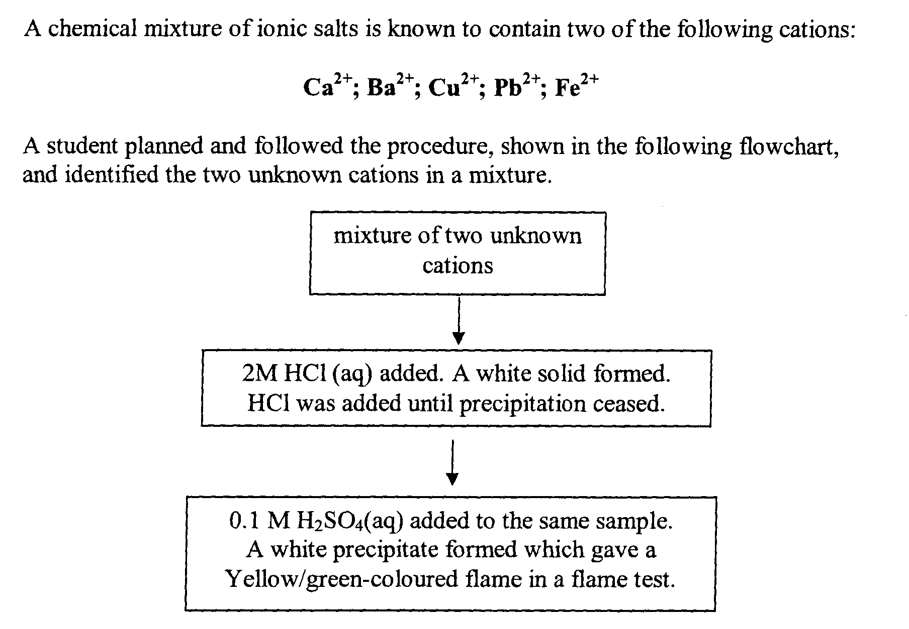

a. Identify the cation responsible for the white precipitate formed upon addition 1

…………………………………………………………………………………………………………………

b. Write a net ionic equation for the reaction which produced the white precipitate upon addition 1
of H₂SO₄

…………………………………………………………………………………………………………………

c. Justify the procedure the student followed to identify these two cations 3

…………………………………………………………………………………………………………………

…………………………………………………………………………………………………………………

…………………………………………………………………………………………………………………

…………………………………………………………………………………………………………………

…………………………………………………………………………………………………………………

…………………………………………………………………………………………………………………

…………………………………………………………………………………………………………………

…………………………………………………………………………………………………………………

…………………………………………………………………………………………………………………

Question 28 (4 marks)
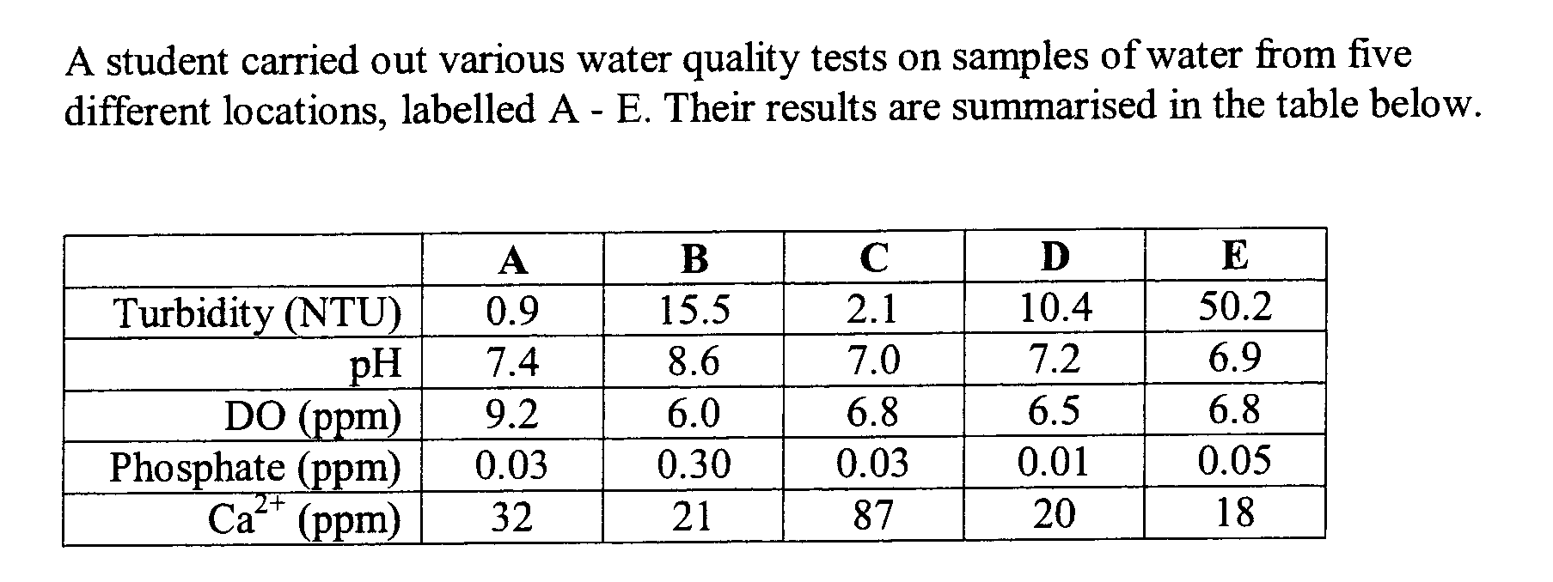

a. Identify the site (A to E) that may have been located next to a market garden. Justify your answer 2

…………………………………………………………………………………………………………………

…………………………………………………………………………………………………………………

…………………………………………………………………………………………………………………

…………………………………………………………………………………………………………………

…………………………………………………………………………………………………………………
- Identify which sample would be classified as the ‘hardest’ and explain one impact that this 2
would have on people using this water

…………………………………………………………………………………………………………………

…………………………………………………………………………………………………………………

…………………………………………………………………………………………………………………

…………………………………………………………………………………………………………………

…………………………………………………………………………………………………………………

Question 29 (6 marks)

As part of your studies of chemistry, you gathered and processed information on features of your town’s water supply.

a. Describe what is meant by the term ‘catchment’ area 1

…………………………………………………………………………………………………………………

…………………………………………………………………………………………………………………

b. For an identified possible water contaminant, describe a suitable chemical test to determine its 2
presence in a water source

…………………………………………………………………………………………………………………

…………………………………………………………………………………………………………………

…………………………………………………………………………………………………………………

…………………………………………………………………………………………………………………

c. Explain how Sydney’s drinking water is generally considered safe, and of a high quality, despite 3
possible sources of catchment area contamination

…………………………………………………………………………………………………………………

…………………………………………………………………………………………………………………

…………………………………………………………………………………………………………………

…………………………………………………………………………………………………………………

…………………………………………………………………………………………………………………

…………………………………………………………………………………………………………………

…………………………………………………………………………………………………………………

…………………………………………………………………………………………………………………

